**Downloading and installation instructions for adding vmware images**

**Please follow all steps…**

**Step 1.**

Please **download 7zip** and **install** onto your system

<https://www.7-zip.org/download.html>

**Step 2.**

Please download and install vmware player 16.2.3

<https://www.vmware.com/sg/products/workstation-player/workstation-player-evaluation.html>

**Step 3.**

Please download the following zipped images for your installation and testing

1. Windows 10 Pro Image - zipped file (about 8 GB)

<https://drive.google.com/drive/folders/1PxVfYdn8YTANqCBUTjehUKyCm1Pd4eBI?usp=sharing>

1. Windows 2016 Server - zipped file (about 11 GB)

<https://drive.google.com/drive/folders/1PxVfYdn8YTANqCBUTjehUKyCm1Pd4eBI?usp=sharing>

**Step 4.**

You must **unzip the 2 Windows images** from Step 3 **using 7zip program** into the following directory, **“C:\Users\xxxxx\Documents\Virtual Machines”** as shown in Figure 4.1 and Figure 4.2.

(Default directory of vmware player)

**\*Note: xxxxx – denotes user name**

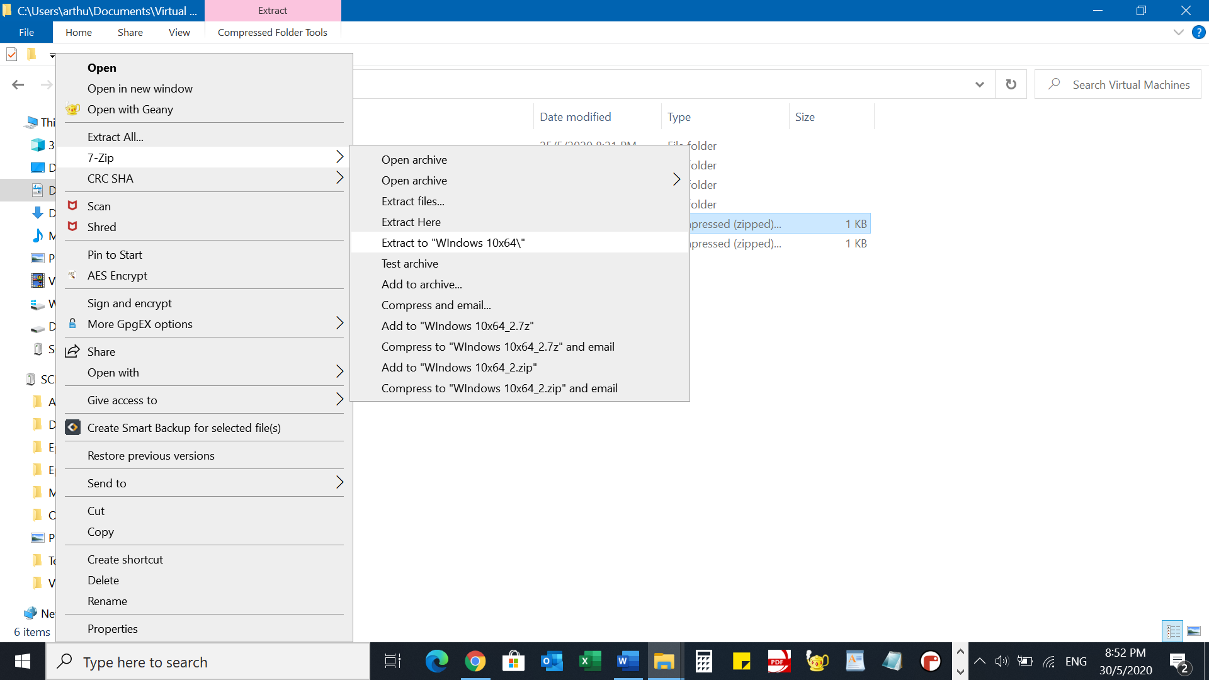

**Figure 4.1**

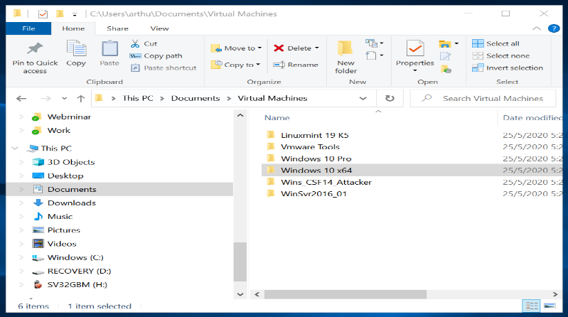

**Figure 4.2**

**Step 5.**

Addin the vmware image to the vmware player.

**Figure 5.1**

**Go to “C:\Users\xxxxx\Documents\Virtual Machines” and double-click on “Windows 10 x64” directory as shown in Figure 5.2**

**Figure 5.2**

**Step 6**

Select “**Windows 10 x64.vmx**” as shown in Figure 6.1

Figure 6.1

**Step 7.**

Repeat the process for “Windows Server 2016”. The final screen on the vmware player would look like Figure 7.1

Figure 7.1

After adding the 2 Windows images, you can proceed with your testing.

**Step 8**

Login to **Windows Server 2016**. The password to login is “**Pa$$w0rd**”

Create a “**command prompt**” shortcut on the Desktop of the Windows 10 and the Windows Server 2016 as shown in **Figure 8.1, Figure 8.2 and Figure 8.3**

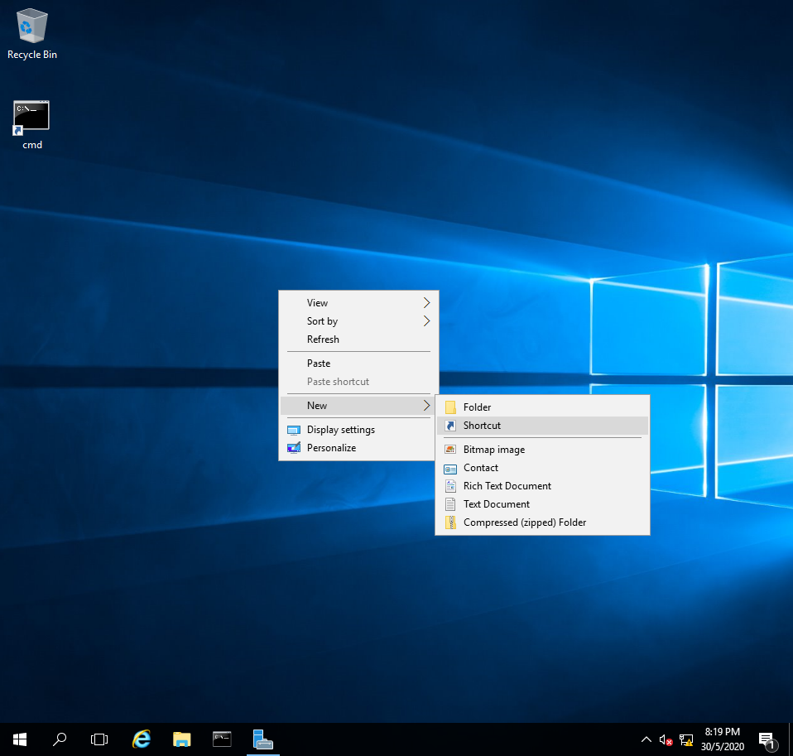

**Figure 8.1**

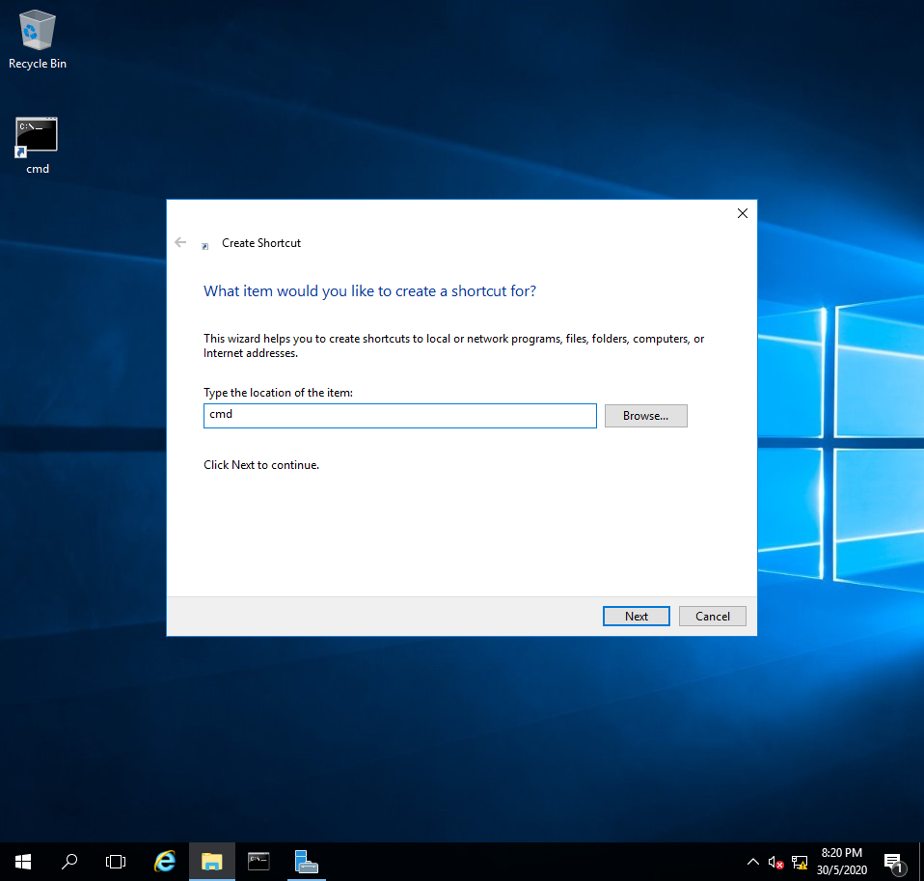

**Figure 8.2**

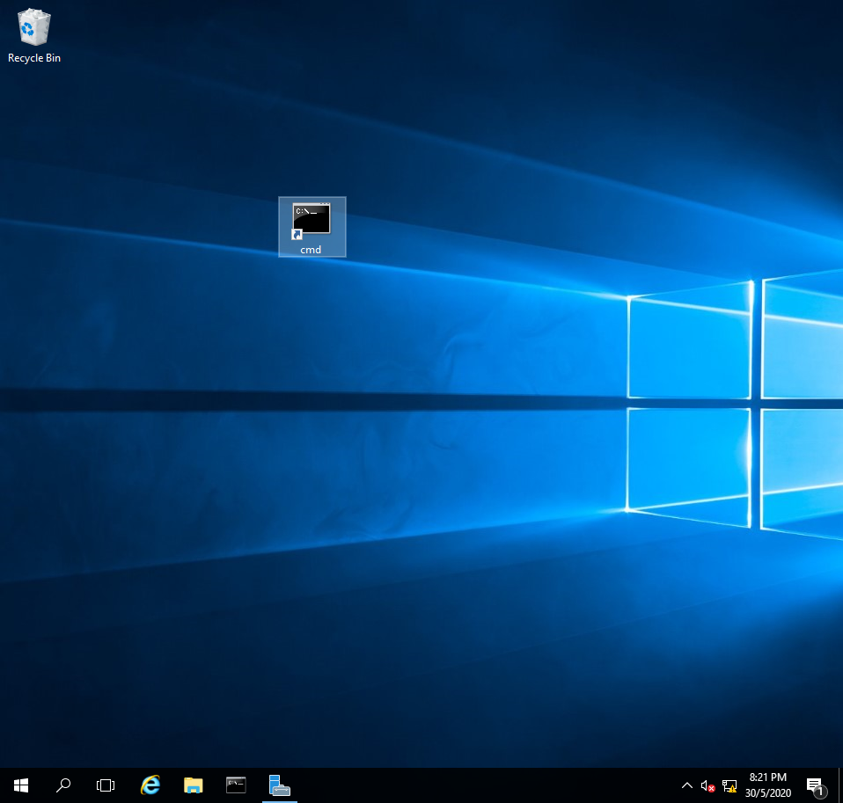

**Figure 8.3**

Double-click on the “**command prompt**” and type **ipconfig**.

Check both **IP address** on **Windows 10** and **Windows Server 2016** by using the command -> **ipconfig**

**\*Please note that your IP address may be different from the screen shown in Figure 8.4\***

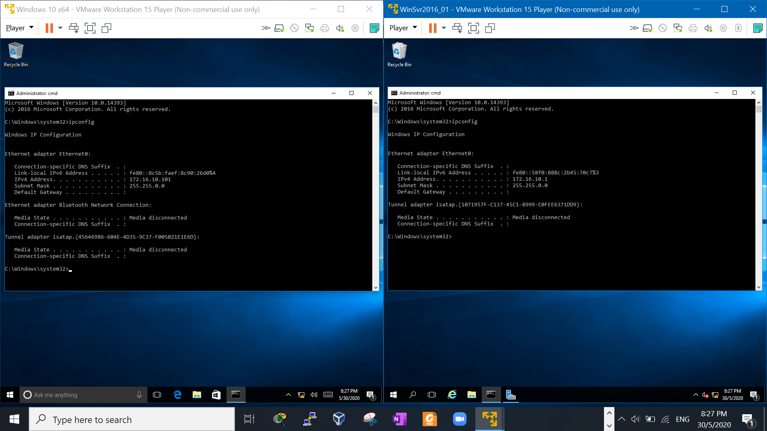

**Figure 8.4**

**Step 9**

Ping each other as shown in **Figure 9.1**

If both can ping each other successfully, then you are ready for the practice exercise.

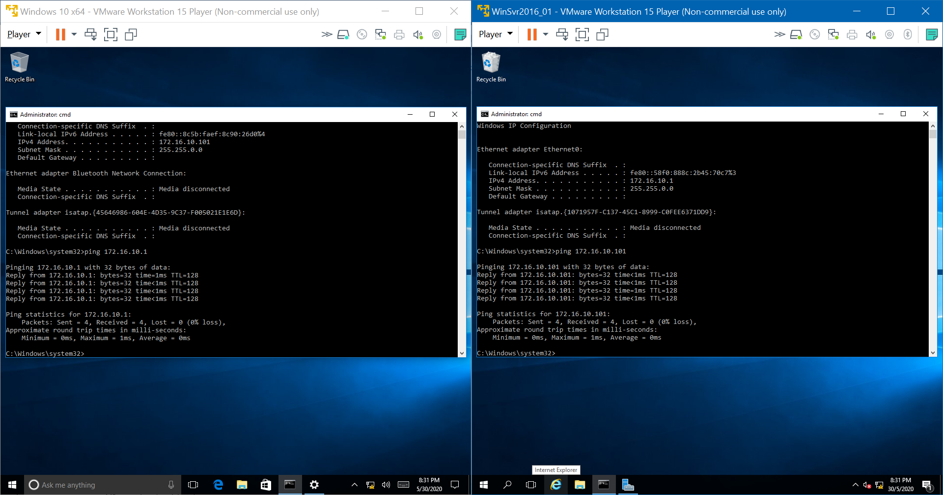

**Figure 9.1**

**\*Please note if ping to Server fails, it could be due to firewall\***

**~~~~~End~~~~~**